Narrow Body Smart Lock
Installation and operation Instructions

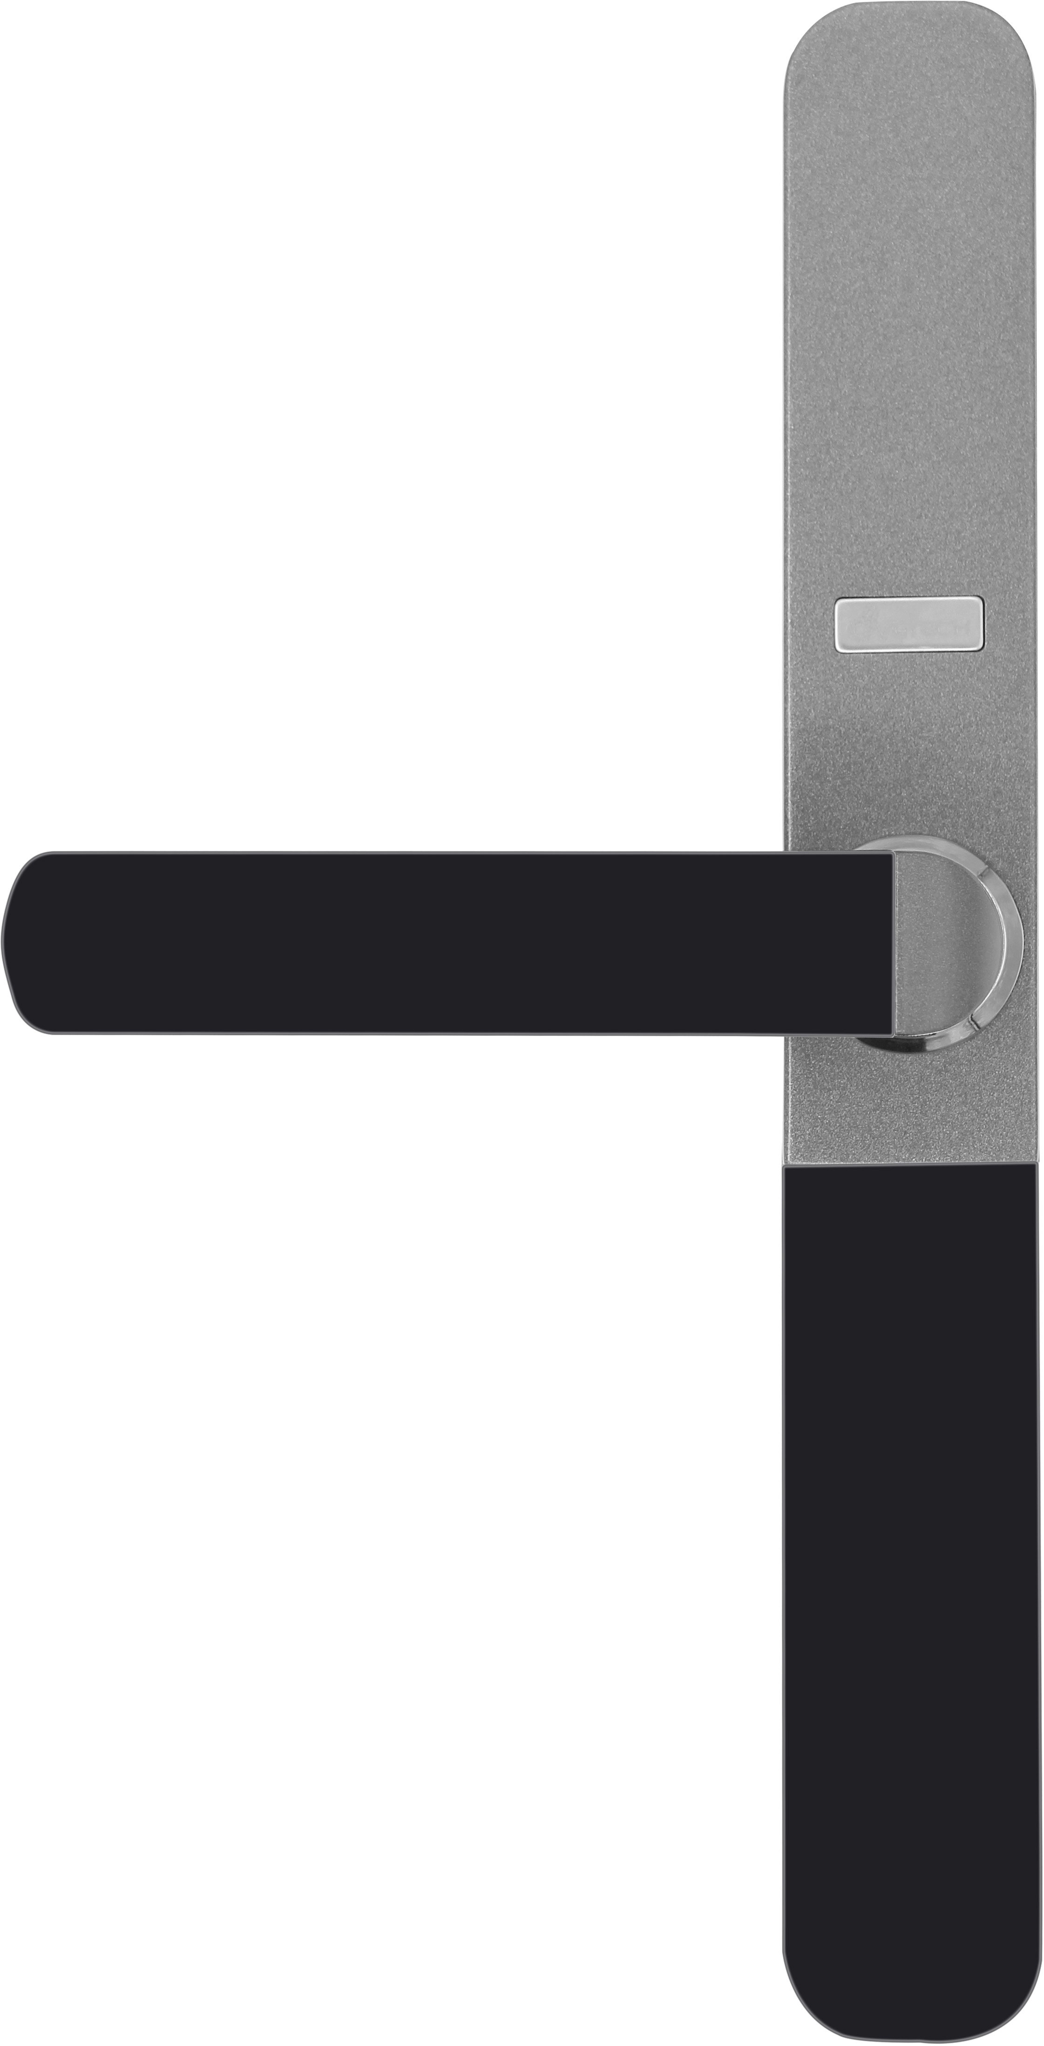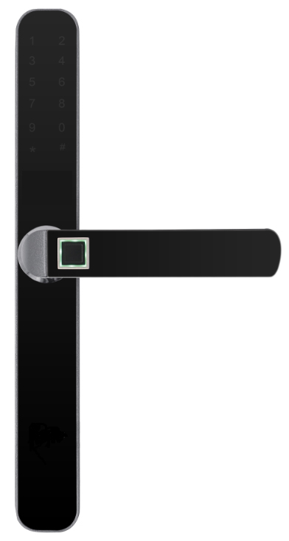

一、Installation method of 01&03 model
Step 1 | Step 2 | Step 3
Determine the opening direction of the door | Install the lock body | Change the direction of the handle
Standing outside the door and facing the door, to determine the opening direction of lock and door. | Select the corresponding lock body according to the door opening direction, install the lock and tighten screws as shown in the diagram. | According to the door opening direction to change the handle direction as shown in the diagram, and adjust the R is open to right in A position, L is open to the left.
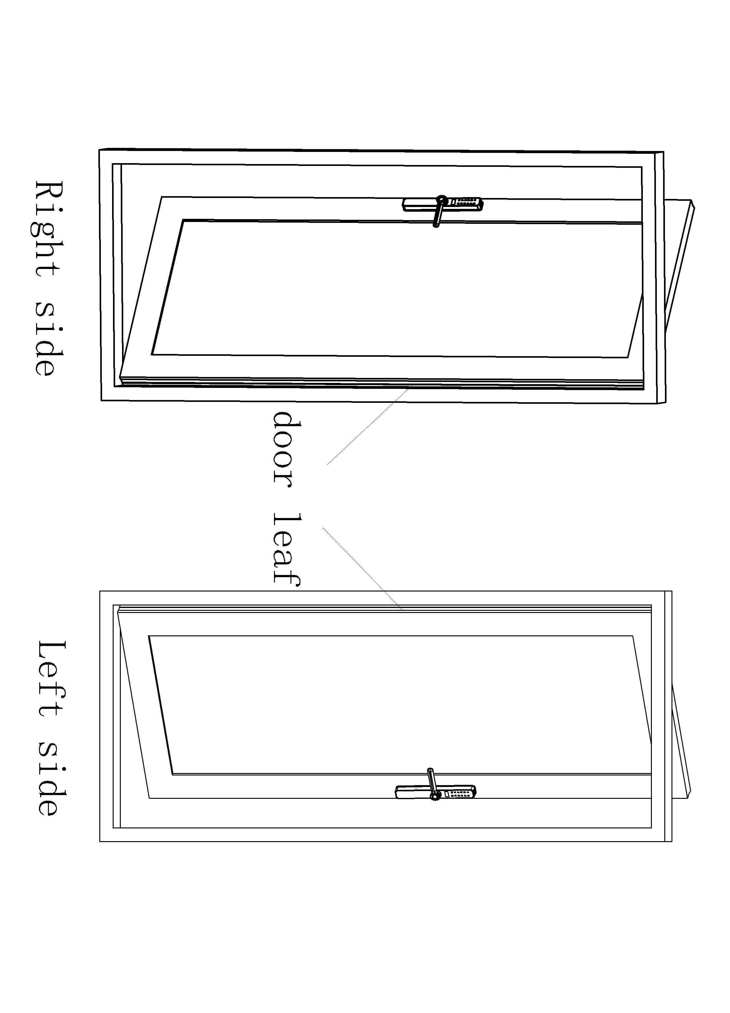 | 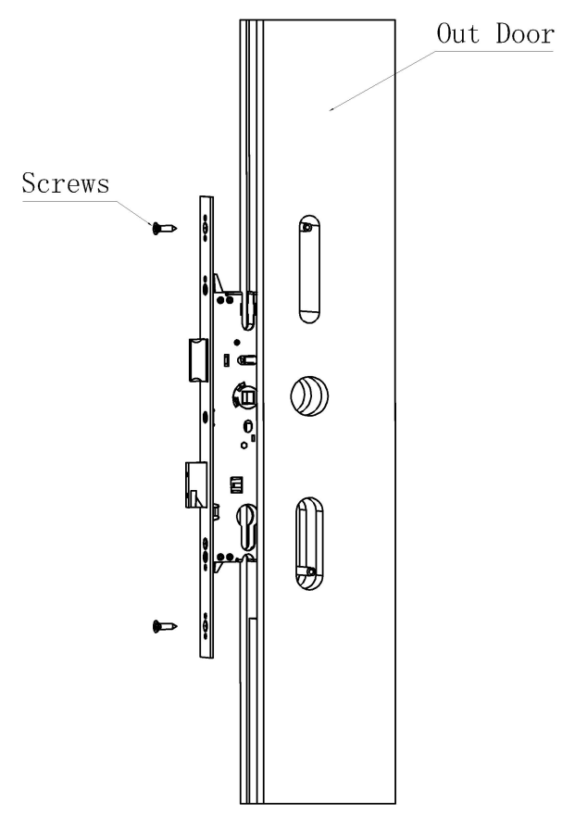 | 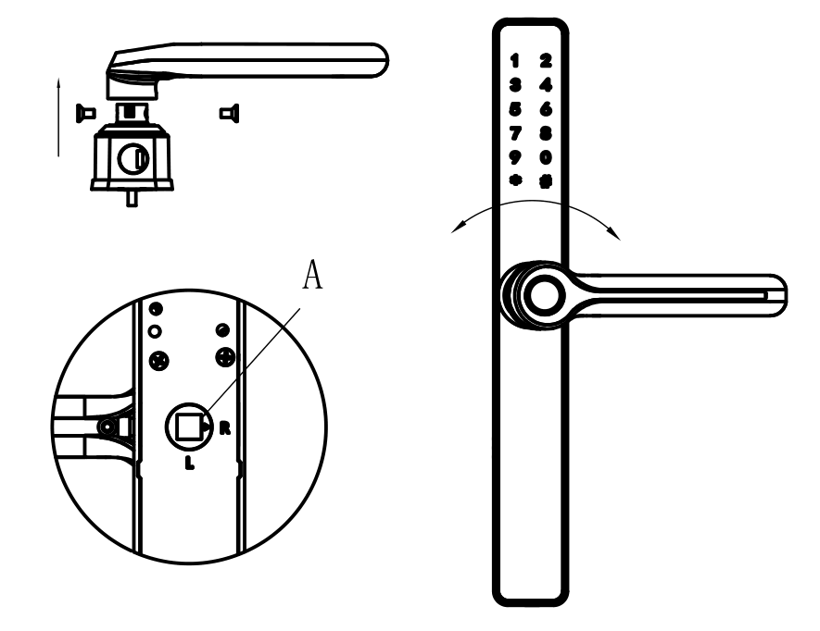
Step 4 | Step 5 | Step 6
Install the front panel |  | Install the back panel
Install the front panel as shown in the diagram, and install the mounting sleeve on the square bar to fix back shroud and tighten screws before taking out the mounting sleeve |  | Install as shown in the diagram
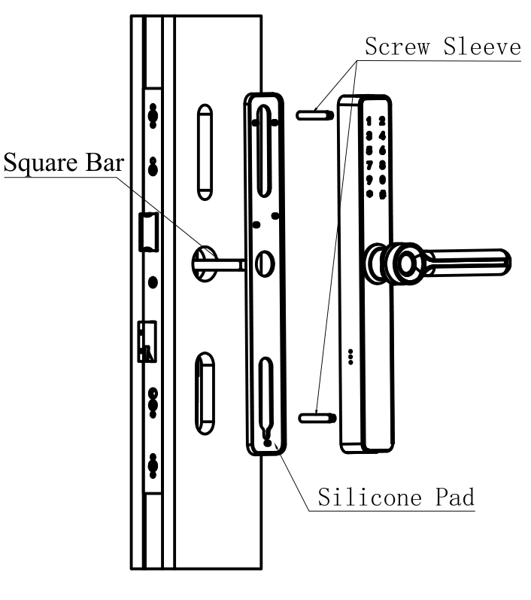 | 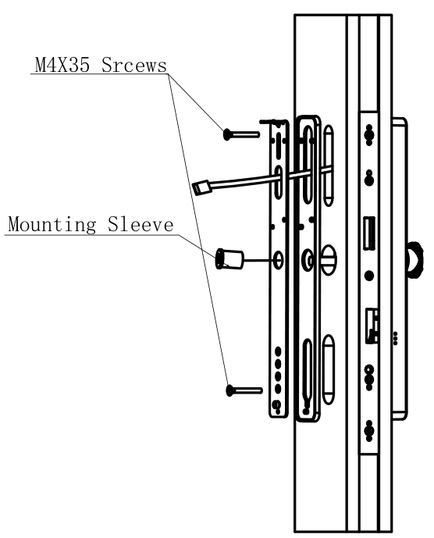 | 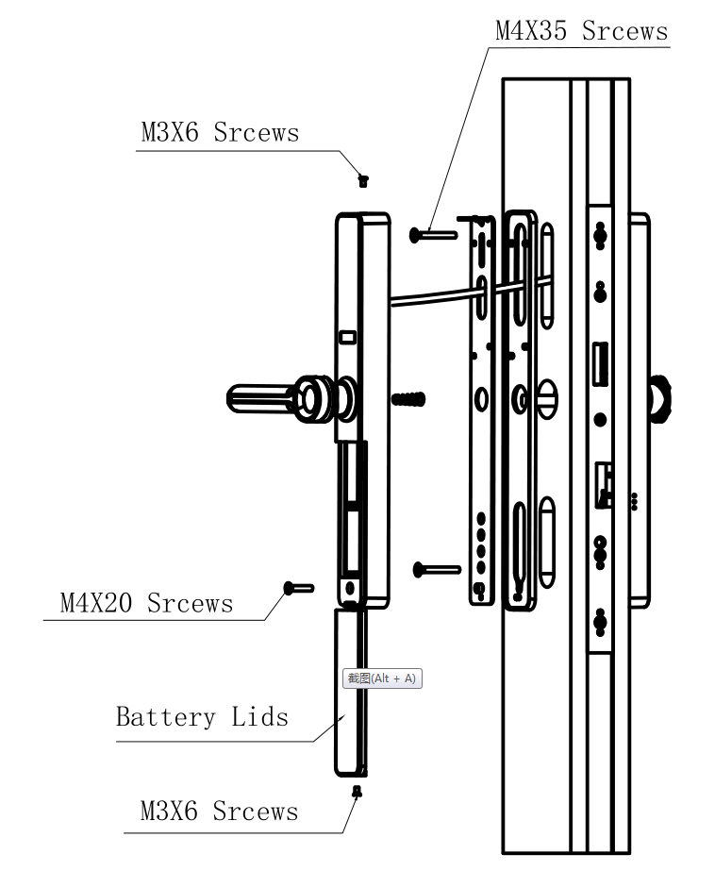
Step 7
Install the buckle plate | Restore factory setting | Emergency power supply
Adjust the corresponding position of the bolt and the buckle plate, so that it is smooth to lock and unlock, then tighten screws. | As shown in the diagram | As shown in the diagram
Technical parameters
Power supply： | 4.5V-6.5V（4 dry batteries） | Quiescent current: | <50uA | Working current： | <400mA
False Rejection Rate： | ≤0.15% | False acceptance rate： | ≤0.00004% | Working Temperature： | -10℃～60℃
Relative humidity： | 20% ～ 93% | Number of fingerprints: | <=100 groups (9 groups of administrators, 91 groups of users)
Number of swiping card: | <=300 groups (9 groups of administrators, 291 groups of users) |  | Number of passwords for door opening: | <=300 groups (9 groups of administrators, 291 groups of users)
key type for opening door | Quantity | Number range | Remark
Administrators | 9 | 1~9 | Administrators can use fingerprint, card or password
Common users | 291 | 10~300 | Common users can use fingerprint (up to 100), card, password or remote control
functional configuration
Unlocking method | Fingerprint, password, swipe card, key, WeChat applet, remote control (optional), App (optional) |  |  | Spare keys | 2 pieces
Code keyboard | 12-key capacitive touch | Magcard | 2 pieces | Voice prompts | Human voice
Locking function | Reverse lift to lock | Security mode | Combination unlocking, virtual password
Suitable door type | Plastic steel door, broken bridge aluminum door, timber door, etc.

Ⅰ. Function and operation

Initial state
The factory engineering password is "123456" to open the door.
After entering the administrator information, the engineering password "123456" will be automatically deleted.

General rules of operation
We will input management fingerprint, management password or management card,they are all called authentication administrator.

authentication administrator.
Enter administrator fingerprint
(card or password)

"#" key is the confirmation key or into the menu function key
"*" key is the clear key/back key, short press to clear the input when entering the password

Enter the door lock function management
Light up the touch screen and press "*#”
Enter function management
Authentication administrator

Press the setting key

In the initial state, press "*+#" after lighting up the touch screen or directly press the setting key on the back panel to prompt to enter the administrator. Voice broadcast: "Add administrator" "Please enter the fingerprint, card or password to be added". After successful addition, it automatically enters the door lock management function. Voice broadcast: "Number 001 added successfully", "1 for adding users", "2 for deleting users", "3 for door lock setting", "4 for adding administrator". Press "#" key to repeat the voice broadcast.

After entering the administrator, lighting up the touch screen before pressing "*+#" (or directly press the setting key on the back panel) to enter the administrator verification status. After the operation, the voice broadcast: "Please verify the administrator", when the administrator is verified successfully, then the door lock function management can be done.
Note: Before the administrator information is entered, the initial password (123456) can be used to open the door. After the administrator information is entered, the initial password is automatically invalid.

Administrator settings
- Enter the administrator information
After entering the management menu, can select 4 to add an administrator and operate with following voice prompts.

Note: In the process of inputing, cannot enter the information that has already been entered. The number of passwords is 6 to 12 characters.

Common user settings

Common user information can be entered into fingerprint, card, password, remote control (optional), and operate with following the voice prompts after entering the door lock function management.
- Enter common user information
After entering the management menu, select 1 to add users and operate with following voice prompts
Note: During the input process, cannot enter the information that has already been entered. The number of passwords is 6 to 12 characters.

Delete users

After entering the management menu, select 2 to delete users. There are two ways to do it as follows:
- Delete by number, each user has a number, such as 001, 002, etc. Every time unlock, the user number will be voiced, as per the voice prompt to enter the number and press the # key to delete.
- Delete as per user information, enter fingerprint, password, card, or remote control to be deleted with pressing # key.
Note: Cannot delete the administrator information who entered the management menu this time

Door lock settings
Function options include 1. Function setting, 2. Volume adjustment, 3. Language setting, 4. Time setting, operate with the following voice prompts after entering the door lock function management
- 1.Function setting
- Turn on or turn off the normally open mode, After turning on the normally open mode, verify the user information to turn on the normally open mode
- Turn on or turn off the dual verification mode, After the dual verification is turned on, common users need to verify the user information of two different numbers before unlocking, the dual verification is not required if entering the administrator information.
- Turn on or off the anti-pry alarm
- Turn on or off the silent mode

Note:
1.Each function seting has two status of turning on and off.If it is off for the last time, the voice will prompt to turn on this time, otherwise it will prompt to turn off.
- 2.Volume adjustment
Press 1 to increase the volume, press 2 to decrease the volume (when the volume reaches the peak, "beeps" sound will be issued to prompt)
- 3.Language setting
Press 1 to switch to Chinese, press 2 to switch to English
- 4.Time setting
Enter the year, month, day, hour, minute according to the voice prompt, press # to confirm to modify the time

Restore factory settings
Press and hold the setting key on the back panel for about 7 seconds until you release the setting key after hearing "beeps", the system will be in restore factory settings condition, all unlocking information and recording will be emptied, the initial password is 123456 if success (for unlocking administrator verification) .

Other instructions
- Enter the wrong password more than 5 times continuously within five minutes, the keyboard will be locked for 90s, the system does not respond to any operation during this period, and it can be released by the administrator through the setting key on the back panel.
- Password anti-peeping function: When open the door with password, enter the password as follows: XXX password XXX; that is you can add some irrelevant codes before and after the password, and then press # to confirm. The password must be included in the input.
- The system will automatically exit every time the operation without any action for more than 12 seconds.
- After the voltage is lower than 4.8V, there will be a low voltage alarm every time unlock, the door lock can be opened for 200 times after the alarm, the unlock is prohibited when over the times until the voltage value is more than 4.8V, please must replace the new battery after the low voltage alarm.

Parts list of 01~03 model
No. | Product name | Qty.（Pcs） | Unit | Remark
1 | Front panel | 1 | Pcs
2 | Back panel | 1 | No
3 | Lock body | 1 | Pcs
4 | Lock buckle plate | 1 | No
5 | Silicone pad | 2 | No
6 | Mechanical key | 2 | Pcs
7 | 8*8*75mm square steel | 1 | Pcs | Screw package
7 | 8*8X90mm square steel | 1 | Pcs | Screw package
7 | Square steel reset spring | 1 | No | Screw package
7 | Cross countersunk head screws  M4X35mm long | 1 | No | Screw package
7 | Cross countersunk head screws  M4X35mm long | 1 | No | Screw package
7 | Double head M4X35mm casing | 2 | No | Screw package
7 | Double head M4X60mm casing | 2 | No | Screw package
7 | ST4.0X25mm Cross countersunk head tapping screws | 5 | No | Screw package
7 | Mounting sleeve | 1 | No | Screw package
7 | Black cross countersunk head screws M3X6mm | 1 | No | Screw package
7 | Hexagon socket countersunk head screws M4x10(black) | 1 | No | Screw package
7 | Hex Wrench | 1 | No
8 | Magcard | 2 | No
Disclaimer: When you open the package, if you find that the some of above contents are not in the box, please contact your local dealer as soon as possible to ensure your use

